EXPERIMENT – 40
AIM :
To analyze soccer player data by identifying top goal scorers, highest-paid players, calculating average age, listing players above average age, and visualizing player distribution by position.

ALGORITHM :
- Create a sample dataset and save it as a CSV file.
- Load the CSV into a pandas DataFrame.
- Sort and display:
- top 5 players by goals
- top 5 players by salary
- Calculate the average age.
- Display players older than the average age.
- Count players by position.
- Visualize the position distribution using a bar chart.

CODE :
import pandas as pd
import matplotlib.pyplot as plt

# Step 1: Create sample dataset and save to CSV
data = pd.DataFrame({
'Name': ['Ronaldo', 'Messi', 'Neymar', 'Mbappe', 'Salah',
'Kane', 'Lewandowski', 'Benzema', 'Haaland', 'Modric'],
'Age': [38, 37, 31, 25, 30, 29, 34, 35, 23, 36],
'Position': ['Forward', 'Forward', 'Forward', 'Forward', 'Forward',
'Forward', 'Forward', 'Forward', 'Forward', 'Midfielder'],
'Goals': [30, 28, 22, 35, 24, 27, 32, 26, 40, 5],
'Salary': [1200000, 1300000, 1100000, 900000, 800000,
750000, 1000000, 950000, 850000, 600000]
})

data.to_csv("players_data.csv", index=False)
print("✅ CSV file created successfully!\n")

# Step 2: Read CSV file
df = pd.read_csv("players_data.csv")

# Step 3: Top 5 goal scorers
top_goals = df.sort_values(by='Goals', ascending=False).head(5)

# Step 4: Top 5 highest salaries
top_salary = df.sort_values(by='Salary', ascending=False).head(5)

# Step 5: Average age
avg_age = df['Age'].mean()

# Step 6: Players above average age
above_avg_age = df[df['Age'] > avg_age]

# Display results
print("=== Top 5 Goal Scorers ===\n", top_goals, "\n")
print("=== Top 5 Highest Salaries ===\n", top_salary, "\n")
print(f"Average Age of Players: {avg_age:.2f}\n")
print("=== Players Above Average Age ===\n", above_avg_age[['Name', 'Age']], "\n")

# Step 7: Bar chart for positions
position_counts = df['Position'].value_counts()
position_counts.plot(kind='bar', color='skyblue')

plt.title("Player Distribution by Position")
plt.xlabel("Position")
plt.ylabel("Number of Players")
plt.grid(axis='y')
plt.show()

INPUT :
A CSV file named players_data.csv containing:
Name, Age, Position, Goals, Salary
(The program creates this file automatically.)

OUTPUT :
✅ CSV file created successfully!

=== Top 5 Goal Scorers ===
Name Goals
Haaland 40
Mbappe 35
Lewandowski 32
Ronaldo 30
Kane 27

=== Top 5 Highest Salaries ===
Name Salary
Messi 1300000
Ronaldo 1200000
Neymar 1100000
Lewandowski 1000000
Benzema 950000

Average Age of Players: 31.80

=== Players Above Average Age ===
Name Age
Ronaldo 38
Messi 37
Lewandowski 34
Benzema 35
Modric 36
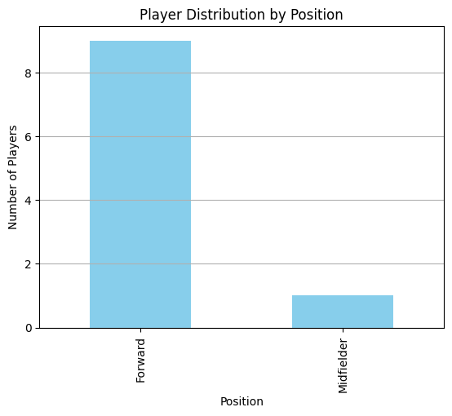

RESULT :
The program successfully analyzes soccer player data, identifies top performers and highest-paid players, computes average age, lists older players, and visualizes player distribution by position.

